1. Stacked bar chart comparing the number of people for each credit scores in different industries.
   1. 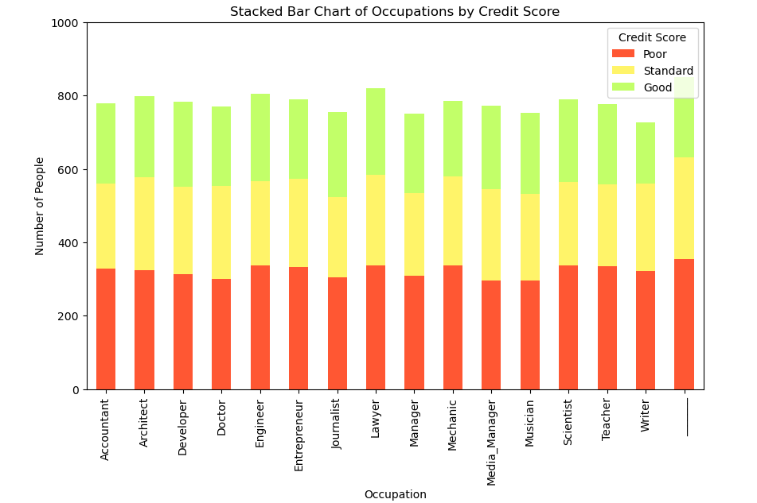Helps the user to visually comprehend the separation of credit scores in each field and to also compare them to other field.
   2. 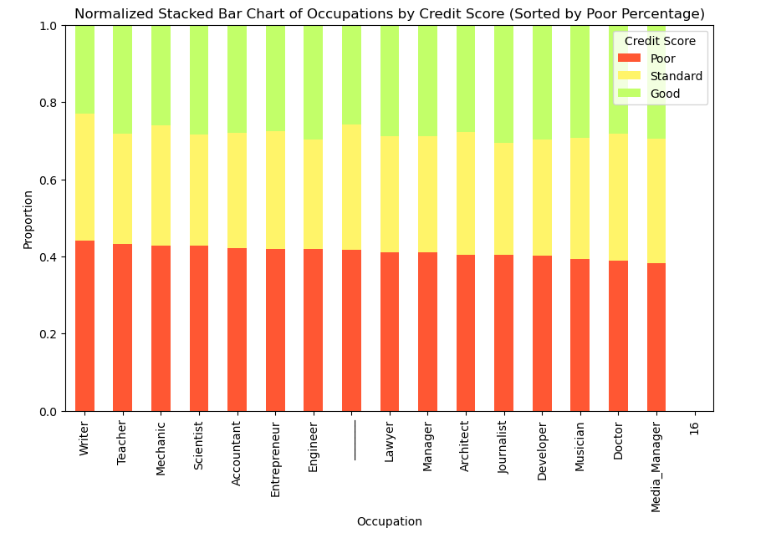The second chart can be used to find the best and worst performers with regards to percentage of ppl with poor, standard and good credit score.
2. 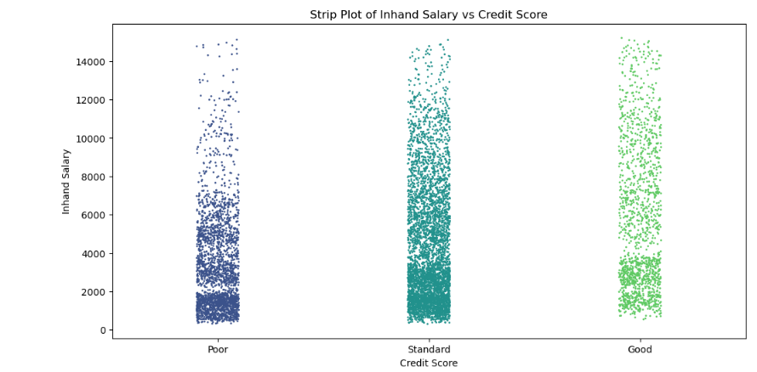Strip/Box/Violin plots to compare the annual income to the credit score.   
     
   Pros:

We can see the distribution and clusters

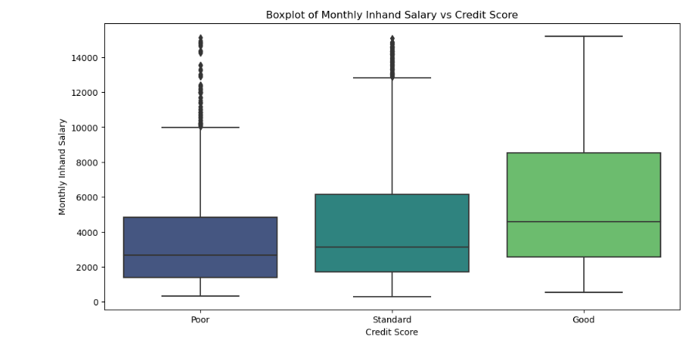

Pros: we can identify where the main chunk of the ppl is and compare more clearly.

We can identify the quantity of outliers

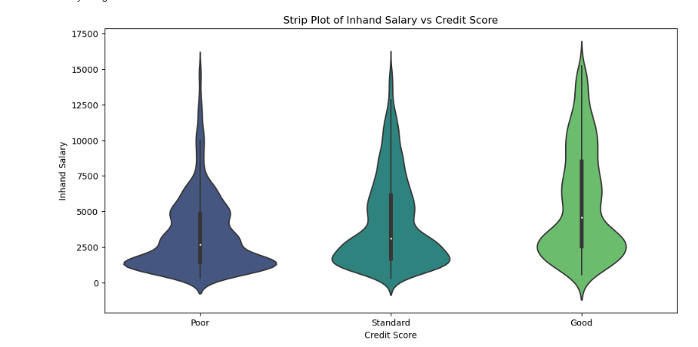

We can see the density distribution and also the Q1-Q3 info

1. Radar Chart

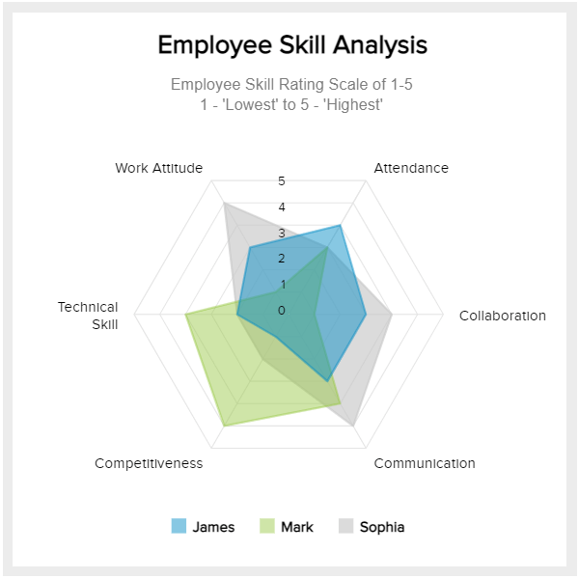Where we can put attributes like

Credit_Utilization_Ratio

Credit_History_Age

Annual_Income

Monthly_Inhand_Salary

Num_Bank_Accounts …

And we can dynamically choose which two demographics to compare. E.g Scientists vs Managers or ppl <30Y vs ppl >= 30Y and so on.